- A scatter plot showing the un-labeled data with V1 on the x-axis and V2 on the y-axis. The plot should be like the one demonstrated in the lecture for the iris data.

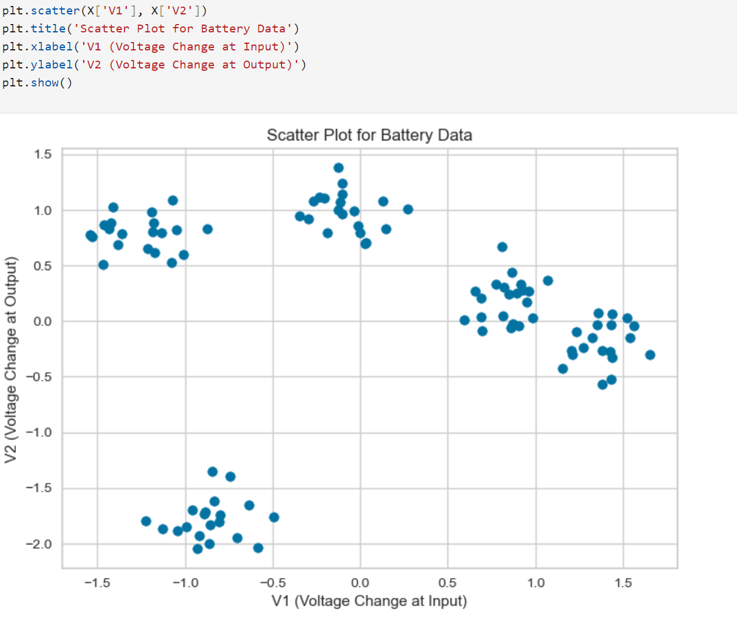

  - b. A plot showing your final clusters with centroids shown for each cluster.
  - 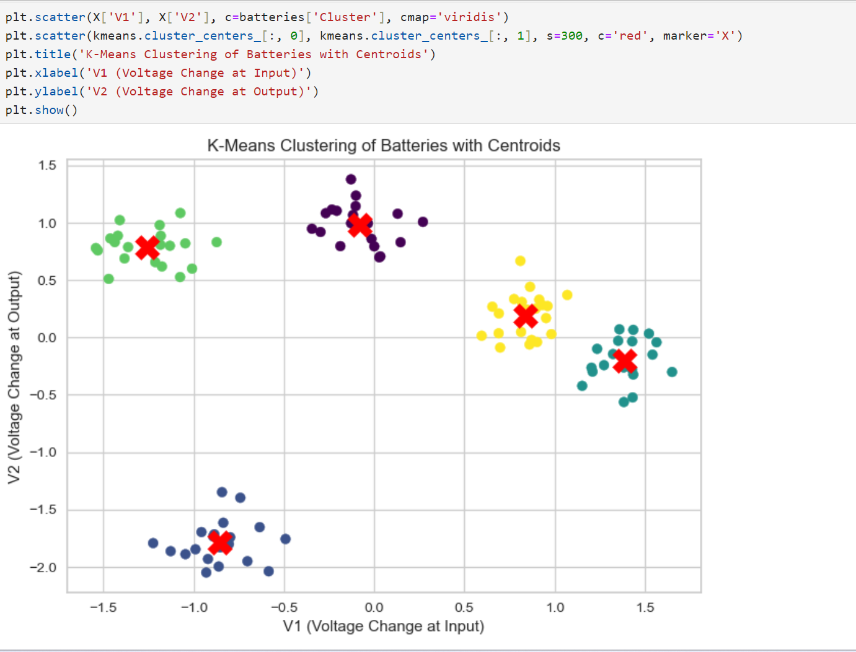

  - c. A plot showing the decision boundaries for your clusters.

  - 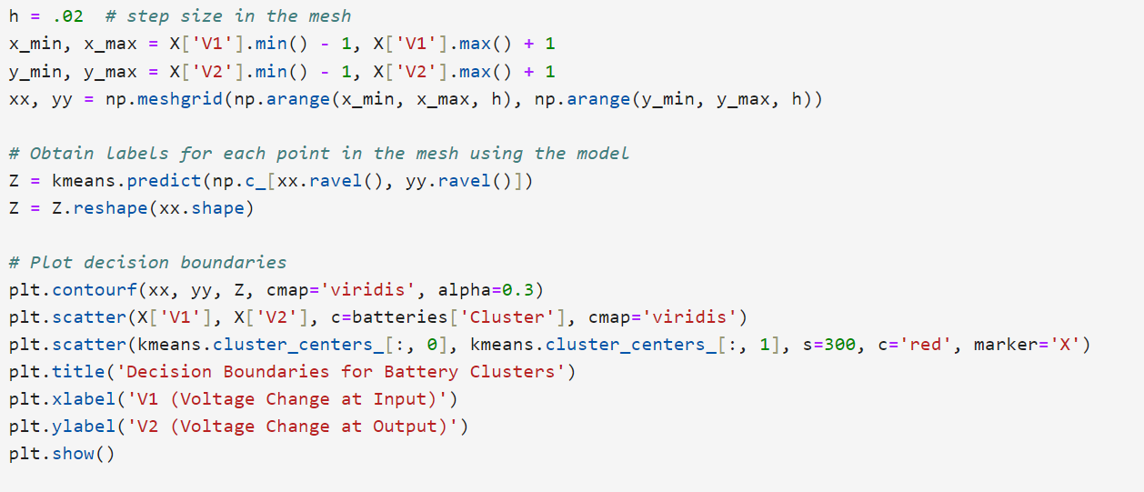
  - 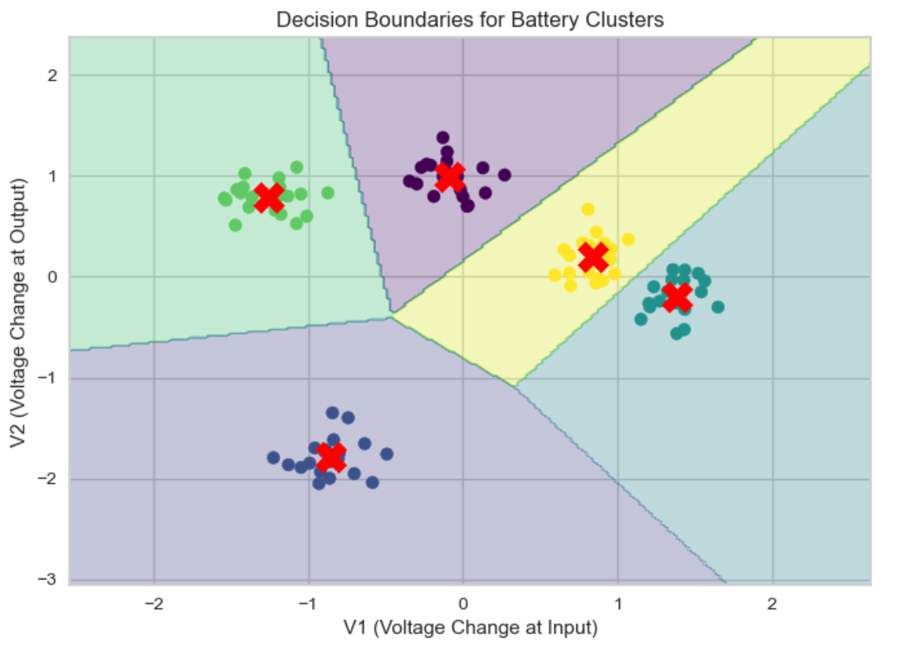
  - d. Plots supporting your decision for the optimum number of clusters (elbow and/or silhouette method). Be sure to explain why you chose the number of clusters based on these plots.

  - 